One of good search engines for through internet for security .

1,VirusTotal
VirusTotal (https://www.virustotal.com)
is an online website that provides a virus-scanning service for files using multiple antivirus engines. It allows users to upload files or provide URLs to scan them against numerous antivirus engines and website scanners in a single operation. They can even input file hashes to check the results of previously uploaded files.
You will access using URL,files,websites to be scanned.
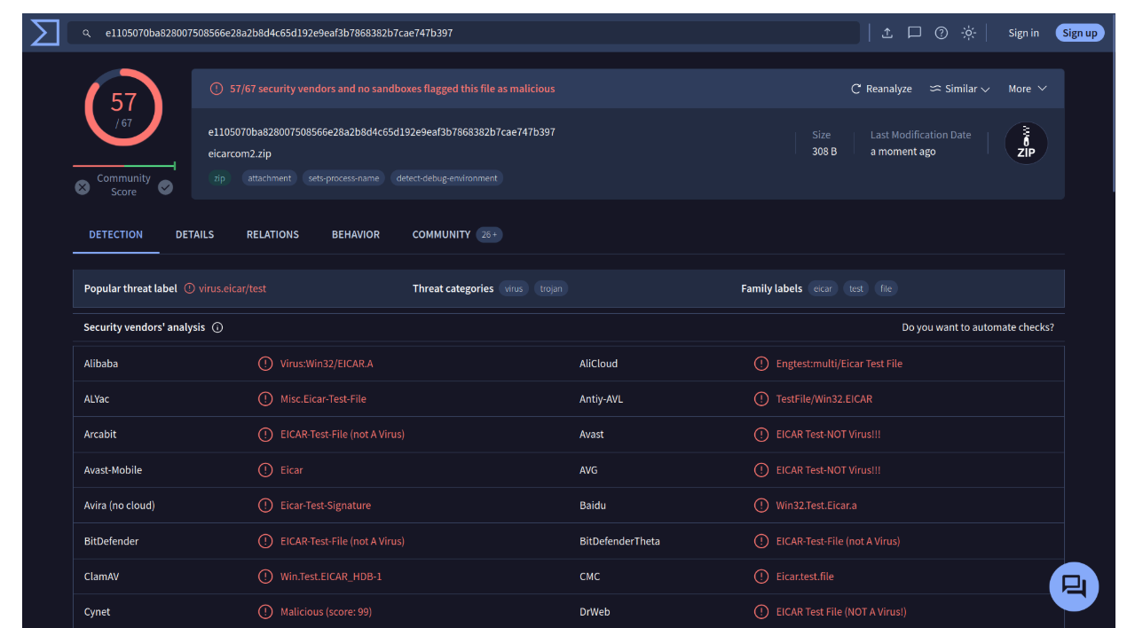

2,Have I Been Pwned

Have I Been Pwned (HIBP) does one thing; it tells you if an email address has appeared in a leaked data breach. Finding one’s email within leaked data indicates leaked private information and, more importantly, passwords. Many users use the same password across multiple platforms, if one platform is breached, their password on other platforms is also exposed. Indeed, passwords are usually stored in encrypted format; however, many passwords are not that complex and can be recovered using a variety of attacks.
Have I Been Pwned (HIBP)(https://haveibeenpwned.com) this the site to check our data is breached or not through entering our email try out this search engine.

And after you upload it if green light appeared means you are safe
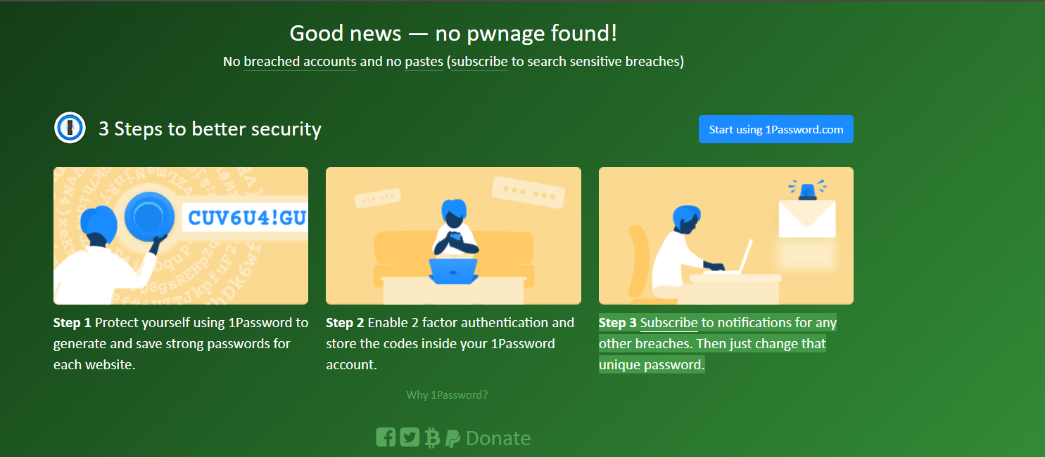
But if red signed appeared you should change your password and use multi-factor authentication
